CENTRAL VIGILANCE COMMISSION (CVC), NEW DELHI
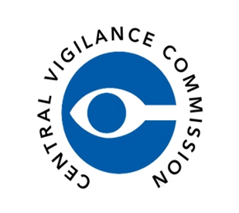
ALL INDIA COUNCIL FOR TECHNICAL EDUCATION, NEW DELHI
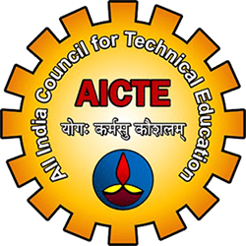
KALINGA UNIVERSITY, RAIPUR (C.G.)
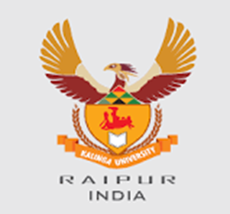
FACULTY OF TECHNOLOGY
Theme: “सतर्कता: हमारी साझा जिम्मेदारी”
“Vigilance: Our Shared Responsibility – Education for Integrity and Transparency”

DAY 2 – Words of Integrity: Essay Writing Competition

Date: 28 October 2025 | Time: 10:30 AM – 11:30 AM
Venue: WBFF 02 (Hybrid Mode)
Organized by: Faculty of Technology & Faculty of Education, Kalinga University, Raipur (C.G.)
Under the Guidance of: All India Council for Technical Education (AICTE) and Central Vigilance Commission (CVC India)
The Faculty of Technology and Faculty of Education jointly organized an Essay Writing Competition titled “Words of Integrity – Academic Writing for Ethical Awareness.” The competition aimed to inspire reflective writing on honesty, integrity, and the role of education in promoting ethical values. The topic for the competition was “Role of Teachers and Students in Promoting Integrity.”
Prof. Dr. Shraddha Verma, Dean, Faculty of Education, opened the event with remarks on the importance of ethics and reflection in academic work. Prof. Dr. V. C. Jha, Dean (In-Charge), Faculty of Technology, appreciated the enthusiasm of participants and stressed the value of honesty in academic growth. Essays were evaluated for originality, clarity, and relevance. Ms. Sneha (B.Ed. Department) was declared the winner for her thoughtful and well-structured essay connecting integrity with education.
The event saw active participation from 76 students and 15 faculty members. The program strengthened ethical literacy and writing skills among students, aligning with NCTE’s vision of academic integrity and social accountability.

Official Links:
Central Vigilance Commission (CVC): https://www.cvc.gov.in
All India Council for Technical Education (AICTE): https://www.aicte.gov.in
Kalinga University: https://www.kalingauniversity.ac.in
#VigilanceAwarenessWeek2025 #IntegrityFirst #CVCIndia #AICTE #KalingaUniversity #EthicsInEducation #TransparencyMatters #SatarkBharat #OurSharedResponsibility

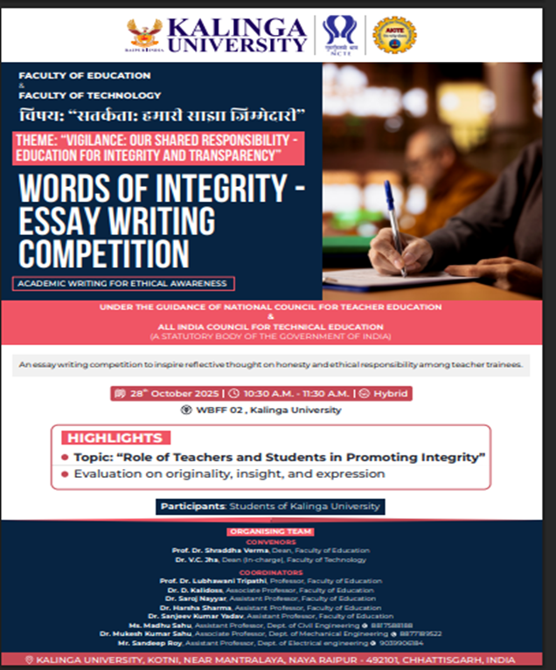 | 